AgriHive

AgriHive is an agricultural start up business that is set on improving Botswana’s agricultural market by addressing issues such as inconsistent local supply of produce as well as working on reducing the reliance of imported agricultural produce.
It has decided to introduce a digital marketplace that enables farmers and buyers in Botswana to transact through a trusted, transparent and structured ecosystem.

- WEBSITE SPECIFICATIONS:
The objective of the website is to develop a web-based platform that connects farmers and buyers in Botswana, enabling efficient buying and selling of agricultural products.

Website Goals:
- To provide farmers with a digital marketplace to sell their products
- To allow buyers to easily search and purchase agricultural goods
- To reduce reliance on middlemen and improve fair pricing
- To enhance communication between stakeholders in the agricultural sector
- To promote local agriculture and food accessibility
Target Audience:
Primary Users:
- Farmers
- Buyers (Households, retailers, businesses)
- Agricultural suppliers
Demographics:
- Ages: 18-70
- Location: Botswana (urban and rural areas)
- Farmers, entrepreneurs, consumers
Technical Aptitude:
- Basic to intermediate digital skills
- Familiar with smartphones and basic web browsing

Website Type:
AgriHive is a dynamic e-commerce and marketplace website. It entails e-commerce functionality (buying and selling products), product listings and profiles

- Information Design and Taxonomy:

Information Architecture:
The website will consist of the following main pages:

- Home
- Login/Register
- Crops
- Horticulture
- Livestock
- Sell
Taxonomy:
- User Access and Account:
-Login
-Register

- Product Categories
-Crops: Maize, Sorghum, Wheat, Legumes, Sweet Reed
-Horticulture: Vegetables, Fruits, Seedlings
-Livestock: Cattle, Goats, Sheep, Pigs, Poultry, Fish
- Functional Features
-Sell: Add/Listing products

- General Navigation
-Home

Site Map: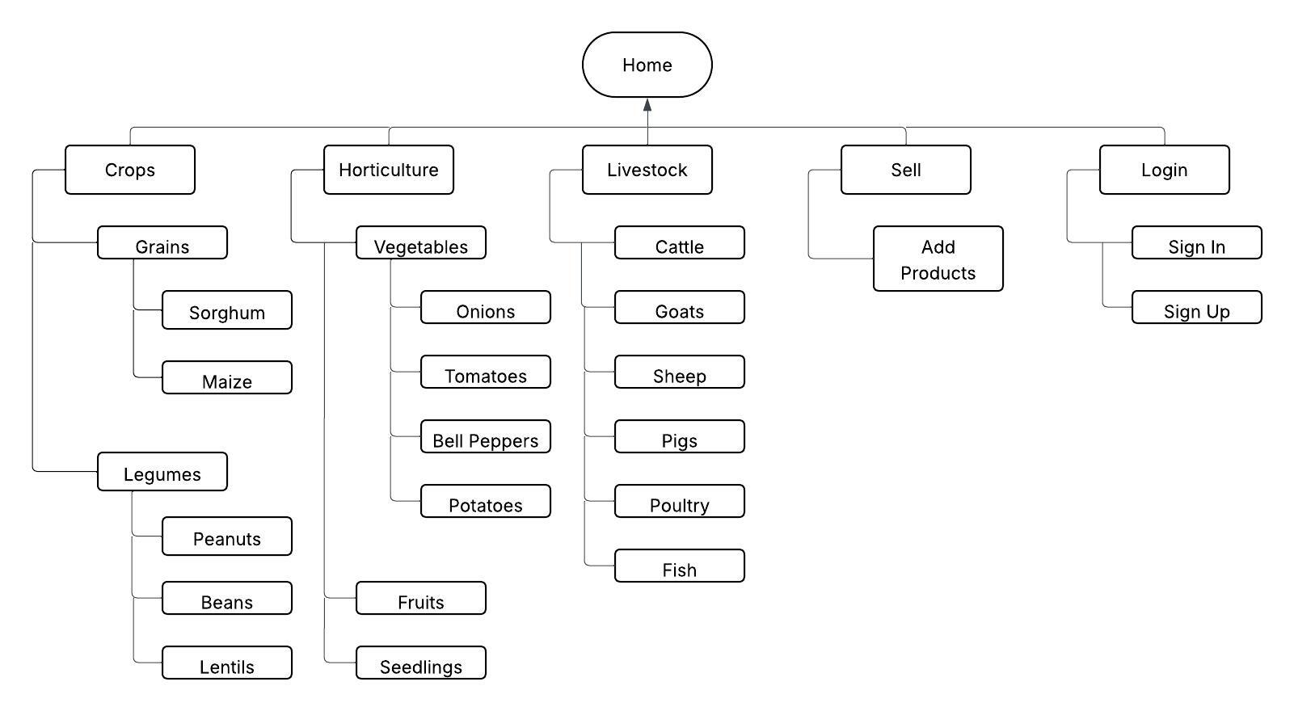

Storyboard:
Buyer Flow:
-User visits Home page
-Clicks on either Crops, Horticulture or Livestock
-Views available products and details
-Contacts farmer or purchases product/s

Farmer Flow:
-Logs in
-Clicks on sell to upload product/s
-Receives messages or orders
-Confirms sale

- Technical Brief

Technology used includes:
-HTML 5
-CSS3
-Bootstrap
-JavaScript

Software Tools:
-Visual Studio Code: The code editor
-Figma: For User Interface design and mockups
-GitHub

Design Considerations:
-Responsive design (mobile + desktop)
-Simple and intuitive user interface
-Fast loading pages
- Accessibility for users with basic technical skills

